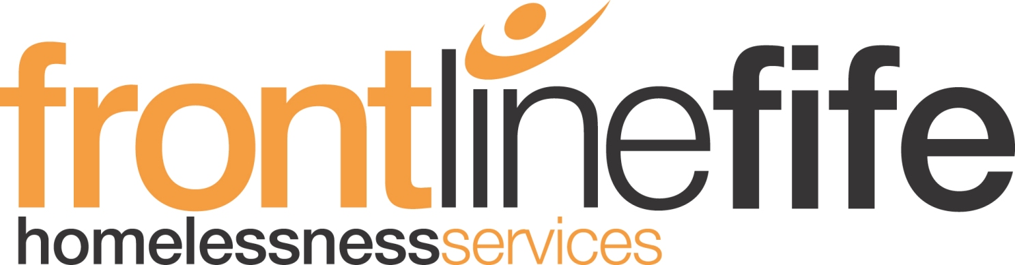

Recruitment Information Pack
About Frontline Fife

As a team of compassionate and unique individuals, we aim to end homelessness through preventative action and by assisting and supporting people to choose the life they aspire to.

Frontline Fife (FLF) is a midsized, Scottish registered charity which works across Fife independently and in collaboration with national and local partners and services.

Our social aim is to end homelessness through preventative action and by tackling the root causes of poverty and inequalities.

Central to all that we do is our commitment to human rights and the fundamental premise that everyone has the right to live in a safe and secure home and should be empowered to make life decisions which matter to them.

We believe homelessness is everyone’s responsibility and therefore it is incumbent upon us all to play our part to prevent homelessness, challenge stigma and exclusion and enable action and the mobilisation of resources to rapidly respond where possible to support those either at risk of homelessness or when in crisis.

Our work is founded on strength-based approaches. We accept everyone’s life experiences can and should be harnessed and developed to realise lasting change.

Our Governance

FLF is governed by a board of trustees having academic, policy, practice and lived experience knowledge of homelessness. There are currently seven trustees serving on FLF’s Board with collective experience in social work; health; children and family work; mental health; supported accommodation and poverty. Such expertise guides and strengthens our charity and adds genuine value to the work we do.

As an explicit commitment to tackling homelessness, in 2017 the Board set out the charity’s strategic position on poverty and homelessness to direct current and future plans.

FLF believe that:
- A secure home is a basic human right
- Homelessness is not a free choice, it is an outcome
- Homelessness is society’s responsibility
- Service delivery should be client focused
- Social justice is for all

Our Practice Values

As a staff team, we jointly review our work and underpinning values. From our most recent review we committed to:

- working with efficiency
- have Integrity
- be responsible
- remain positive about our business, our services and the people we work with

Our Funders

FLF continues to be funded through grant awards from the Scottish Government, Local Government, and the Fife Health and Social Care partnership. It also generates income through winning competitive tenders and contract work either independently or in collaboration with other agencies and through public donations. Our main funder which we are grateful for is Fife Council.

An Overview of Our Services

Frontline Fife provides a comprehensive range of services for people at risk of and experiencing homelessness. All our services are either regulated under the appropriate governing body e.g. Care Inspector or are quality assured through formal accreditation schemes (e.g. Scottish National Standards for Information and Advice Providers) and performance monitoring. The following gives a brief overview of our current service provision.

- Support through housing and homeless advice including the provision of free, confidential and independent advice on a wide range of housing issues, in court lay representation for rent arrears and mediation support for tenancy sustainment.
- Short-term housing and Brief Intervention support to enable individuals to keep their home and prevent them from losing their tenancy or becoming homeless.
- Accommodation services directly manage a limited number of properties throughout Fife on behalf of the local council. This includes emergency accommodation and temporary accommodation which can be accessed by anyone who is single and determined as unintentionally homeless.
- Advice for young people is offered to help prevent young people from becoming homeless. FLF’s Leaving Home Education programme equips young people with essential skills and knowledge for leaving home and independent living.
- Drug and alcohol recovery support is open to those who choose to begin their road to recovery or who need support to sustain their recovery programme once settled in their community. Practical support and assistance are offered to help people manage their addiction to enable them to achieve their goals and to live independently.
- Employment Support is provided in partnership with Fife Employment and Training Consortium. We provide dedicated employment support to adults at risk of homelessness or living in temporary accommodation who choose to seek employment or wish to access education and/or volunteering.
- Project Work which supports Inclusion current project work includes working with families and supporting neurodiversity.

Our Contribution & Service User/Supporter Feedback

Each year we measure our performance and seek feedback on the contribution we make.

As an example of our impact and contribution, in 2021-22 our performance data showed that we offered housing advice to over 680 people; provided almost 200 people with a secure and safe place to stay and delivered Leaving Home Education sessions to 1700 young people.

Feedback given since 2015 includes:

“Being at home means having my own secure tenancy and knowing that I will not have to move again in the foreseeable future. Home means security and peace of mind.” (STHS Client, 2015)

“I love getting up in the morning. I now feel I am worth something.” (Recovery Link Client, 2016)

“I have chosen to continue with support whilst settling into my new tenancy to give me the best chance of keeping my flat.” (Temporary Accommodation Client, 2017)

“The work Frontline Fife does is really incredible, so it makes me proud to be able to contribute to their efforts for the second year.” (Fundraiser, 2018)

“I now know that there are places near me to get help so if I was in this position I could go there.” (Housing Advice Client, 2021)

Information about Homelessness in Scotland and Fife

At the present time, national data shows that Homelessness is increasing in Fife at a disproportionate rate relative the rest of Scotland. Available figures for 2019/20 showed that, of the homeless applications made across Scotland, Fife recorded the second highest rate per local authority area (2622), exceeded only by the City of Glasgow. For 2021/22 the number of homeless applications made in Fife was 2501. Although this is a 2% decrease on the previous years, Fife ranks the third highest for these figures when compared to all local authority areas in Scotland.

The Scottish Government has made ending homelessness a high priority and is currently investing £53.5 million to support councils and partners to prioritise settled accommodation for all. This is being implemented through rapid rehousing transition plans and the upscaling of Housing First for people facing the most significant challenges.

The Government is committed to person-centred and trauma-informed support delivered through a ‘no wrong door’ approach. This means that homelessness support should fit around a person's individual needs/circumstances and that services should be accessed through a single process/door. This approach - of listening to and supporting the needs of each unique individual - is central to the values and work of FLF.

Links to Key Policy Documents
https://www.gov.scot/publications/ending-homelessness-together-annual-report-2022/
https://homelessnetwork.scot/shared-spaces/
https://www.fife.gov.uk/kb/docs/articles/housing/homelessness-and-prevention
https://www.local.gov.uk/re-thinking-homelessness-prevention

Recruitment: Applying to Work with Frontline Fife

When applying to work with Frontline Fife, we advise every potential candidate to take time to review the information made available in this pack, review the job description and the information on how to apply which includes deadlines and other details.

NB: Not all jobs are recruited in the same way, so it is important that you read the information about applying in the advertisement for each job as well as the information in this pack.

As an organisation which supports diversity and inclusion, we encourage all peoples to apply. We also encourage potential candidates thinking about applying to contact us for an informal chat. We want to hear from anyone who is considering working with us. We also welcome feedback for improvement. For an informal chat or to find out more or give feedback then contact us by telephone on 01592 430 800 or email info@frontlinefife.co.uk.

Employee & Wellbeing Benefits

- 32 days annual leave per year with 1 day additional per year served up to 5 years (pro rata).
- Flexible and remote working arrangements.
- Competitive employer/employee Pension Contribution Scheme.
- Business travel allowance.
- Ongoing professional learning and development.
- Free access to an employee assistance programme with confidential advice/counselling support.
- Wellbeing and Lifestyle benefits e.g. discounts on lifestyle benefits, Gym Memberships and access to membership scheme e.g. Blue Light Membership Scheme.
- Where appropriate, welcome payment for PVG check and SSSC registration fee.

Want to Find Out More?

To find out more about the post and for initial inquiries, we welcome having a good conversation with all candidates. To arrange an informal chat about the role(s) you are interested in then please do not hesitate to contact shona.glover@frontlinefife.co.uk.

To apply for a post, please submit your application form to shona.glover@frontlinefife.co.uk by the closing date noted above.

Successful Candidates are subject to PVG Disclosure checks. Successful candidates securing a post regulated by the Care Inspectorate must register with the SSSC and must meet the required standards for the post within the permitted time as directed by the SSSC.

Frontline Fife, as a Disability Confident employer, is committed to supporting job applicants and staff with a disability or long-term health condition. We commit to offering an interview to disabled people when the essential job criteria are met.

Frontline Fife Registered Charity: Charity No SC021832

